**Year 8 Chemistry End of Topic Test 2013**

Name:_________________________ Mark: /64

**Multiple choice answer grid**

**1** A B C D

**2** A B C D

**3** A B C D

**4** A B C D

**5** A B C D

**6** A B C D

**7** A B C D

**8** A B C D

**9** A B C D

**10** A B C D

**11** A B C D

**12** A B C D

**13** A B C D

**14** A B C D

**15** A B C D

**16** A B C D

**Multiple Choice**

**1.** Chemists use symbols to identify each element. Which of the following is **TRUE** about symbols.

A They mostly contain one or two letters.

B They always use the first and second letter of the element name.

C They are arranged in the periodic table alphabetically.

D They must use only capital letters.

**2.** Identify the **correct** statement about the properties of compounds.

A The properties of compounds are impossible to describe.

B The properties of compounds are different to those of the elements they are made from.

C The properties of compounds are the average properties of the elements that make them up.

D The properties of compounds are the same as the elements they are made from.

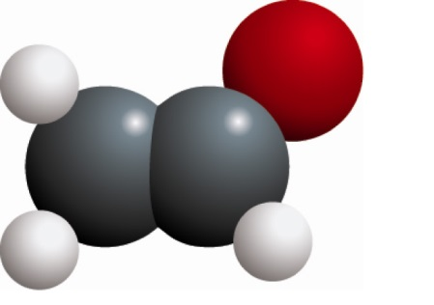**3.** Identify what the chemical structure shown here represents.

A A molecular element

B A lattice element

C A molecular compound

D A lattice compound

**4.** The third shell in an atom holds:

A Up to 18 electrons.

B Up to 2 electrons.

C Up to 8 electrons.

D Up to 20 electrons.

**5.** An atom consists of:

A A nucleus containing neutrons and protons, surrounded by a cloud of electrons.

B Central neutrons, surrounded by a cloud of electrons and protons.

C Central electrons, surrounded by a cloud of protons.

D A mixture of protons and electrons spread evenly in a space.

**[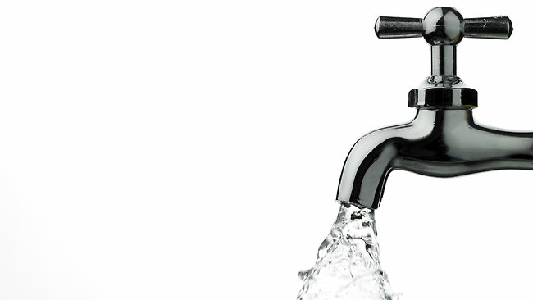](http://www.google.com.au/url?sa=i&rct=j&q=tap+water&source=images&cd=&cad=rja&docid=_KbzInqzCRl9LM&tbnid=5Ewef8l7lEGmCM:&ved=0CAUQjRw&url=http://www.news.com.au/money/money-matters/we-pay-2000-markup-on-water-choice/story-e6frfmd9-1226659029052&ei=wYU2Ur3vPISVkwXa8oBA&psig=AFQjCNHM_r-x7rgG8fO5fzG-H5Skzx9jFg&ust=1379391292538838)6.** **Tap** water is best described as:

A An element

B A compound

C A mixture

D An alloy

**7.** The mass number in an atom can be described as:

A The number of electrons plus the number of protons in an atom.

B The number of electrons in an atom.

C The number of neutrons plus the number of protons in an atom.

D The number of neutrons plus the number of electrons in an atom.

**8.** How many different types of atoms are known about?

A 893

B 35

C 117

D 302

**9.** Which of the following in NOT a part of the Atomic Theory of Matter?

A All matter is made up of atoms.

B Elements are made up of more than one type of atom.

C Atoms cannot be created or destroyed but rearranged to make new substances.

D Compounds are made up of more than one type of atom combined together.

**10.** How many of the known elements occur naturally?

A 92

B 105

C 67

D 97

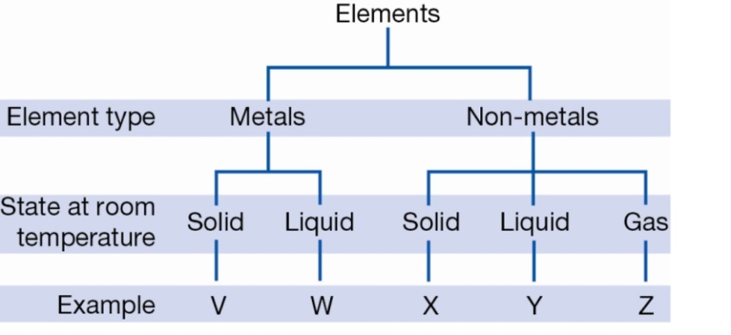**11.** The chart below divides elements into 5 groups where the letters V, W, X, Y and Z represent an example of each.

Given that bromine is the only non-metal liquid at room temperature, it can be inferred that bromine could be:

A Y only

B W or Y

C W only

D X, Y or Z

**12.** The conductivity of a metal is a measure of how well the metal transmits an electrical current. Usually, the conductivity will change with temperature as shown for four metals in the graph below.

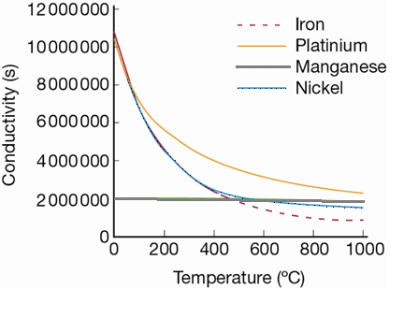

According to this graph, the best conductor at 700°C is:

A iron

B platinum

C manganese

D nickel

**13.** Choose the **most** correct answer to finish the end of the following question

On the periodic table, each element has a unique symbol:

A Because each element has a different mass number.

B Because not all countries speak Latin.

C So that the elements can be internationally recognised.

D So that the elements are easier to write down.

**14.** Look at the diagram below. What structure is it illustrating?

[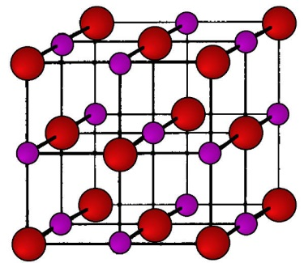](http://www.google.com.au/url?sa=i&rct=j&q=crystal+lattice&source=images&cd=&cad=rja&docid=maVoccP3sZaCtM&tbnid=uImEZ47vKw-YDM:&ved=0CAUQjRw&url=http://www.stat.org.au/Chemistry%20in%20our%20Lives/Solid.htm&ei=HrQ2UtyMI4GNkAWk9YGwBQ&psig=AFQjCNG4IsVUQ9YEhJcosk5-c11CgH5jWg&ust=1379403154565927)A Metallic lattice.

B Monatomic element.

C Non-metallic lattice.

D Molecular element.

**15.** Solder is an alloy (metal mixture) of tin and lead. It is used to connect electrical wiring together because it conducts electricity well and has a low melting point, but sets hard once it’s cooled.

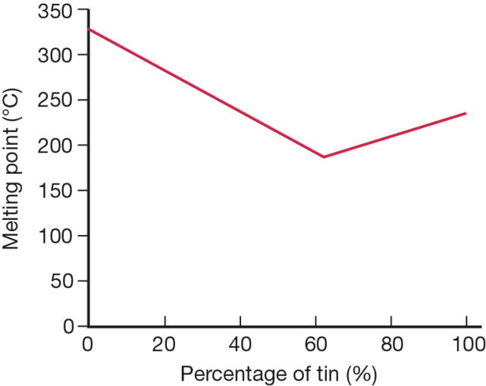The melting point of the solder alloy depends on the proportions of tin and lead in the solder.

Mark wants to use solder to connect some copper wires to a very sensitive electrical circuit. It is important that the electrical circuit does not get too hot so Mark must find the solder alloy with the lowest melting point. Use the graph below to determine what type of solder Mark should use to protect his 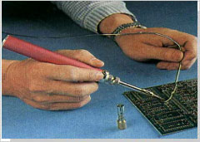electrical circuit.

A 0% tin and 100% lead

B 50% tin and 50% lead

C 60% tin and 40% lead

D 100% tin and 0% lead

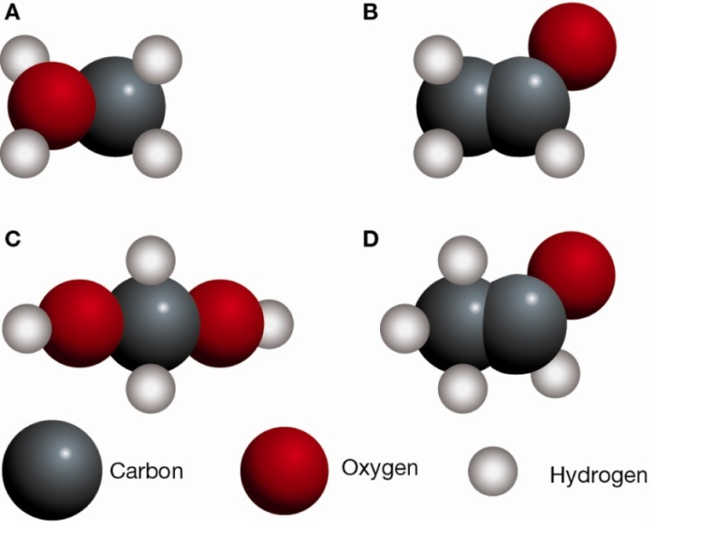**16.** The molecular formula for a compound tells you what type of atoms are in the molecules and how many of each. For example, the molecular formula for water H2O tells you that there are two hydrogen atoms (H) and one oxygen atom (O) in each molecule of water.

A common compound found in coffee, bread and ripe fruit is acetaldehyde, which has the molecular formula C2H4O. Which of the following diagrams would best represent a molecule of acetaldehyde?

**Short Answer**

**1.** Write a definition and draw a diagram for each of the following: (10 marks)

**a)** Element

**b)** Atom

**c)** Molecule

**d)** Compound

**e)** Mixture

**2.** **a)** Sketch a molecule of NH3. (1 mark)

**b)** What is the chemical formula for the molecule shown below. (1 mark)

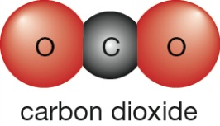

**3.** Name the only two elements that are liquid at room temperature. (1 mark)

**4.** Fill in the following table. (10 marks)

|  |  |
| --- | --- |
| **Symbol** | **Name** |
| Al |  |
| Ca |  |
| Au |  |
| He |  |
| Mg |  |
| Na |  |
| Li |  |
| B |  |
| N |  |
|  | Hydrogen |
|  | Oxygen Gas |
|  | Neon |
|  | Berrylium |
| K |  |
|  | Chlorine |
|  | Carbon |
| F |  |
| S |  |
|  | Silicon |
|  | Phosphorus |
| Ar |  |
|  | Oxygen |

**5.** Air is an example of a gaseous mixture. (2 marks)

What is the name of an element found in air?

What is the name of a compound found in air?

**6.** Explain the difference between a miscible liquid and an immiscible liquid. (2 marks)

________

________

________

________

**7.** Fill in the table using the information listed below. (9 marks)

Shiny, malleable, brittle, does not conduct heat or electricity, solid at room temperature, dull, good conductor of heat and electricity, ductile, solid or gases at room temperature.

|  |  |
| --- | --- |
| Metallic elements | Non-metallic elements |
|  |  |
|  |  |
|  |  |
|  |  |
|  |  |

**8.** Calculate the following for the element below. (5 marks)

Atomic number:

Mass number:

Number of protons: _

Number of neutrons _

Number of electrons _____

**9.** Match the term with its definition by writing the correct number in each box. (7 marks)

Sub Atomic Particle 1. An elements made up of a single atom

Solution 2. Solid not dissolving in a liquid.

Colloid 3. A table showing the known elements

Molecular element 4. The particles which make up an atom

Periodic Table 5. Solid dissolving in a liquid.

Suspension 6. Larger solid particles not dissolving in a liquid.

Monatomic element 7. A cluster of atoms

**SOLUTIONS**

**Multiple choice answer grid**

**1** A B C D

**2** A B C D

**3** A B C D

**4** A B C D

**5** A B C D

**6** A B C D

**7** A B C D

**8** A B C D

**9** A B C D

**10** A B C D

**11** A B C D

**12** A B C D

**13** A B C D

**14** A B C D

**15** A B C D

**16** A B C D

**Short Answer**

1. Define, and draw a diagram of, each of the following: (8 marks)

One mark for each description and one mark for each diagram

a element a pure substance made of one type of atom,

As long as all atoms look the same

atoms with the same number of protons

More than one atom joined in some way

b molecule A group of atoms bonded together

More than one type and joined in some way

c compound More than one type of atom bonded together

d mixture More than one atom not combined together.

2. a) Sketch a molecule of NH3. (1 mark)

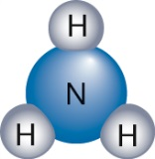

b) What is the chemical formula for the molecule shown below. (1 mark)

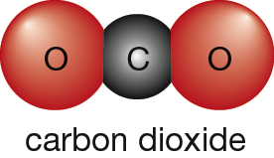 CO2 must have 2 in subscript

**3.** Name the only two elements that are liquid at room temperature. (1 mark)

Mercury and bromine

4. Fill in the following table. (10 marks)

|  |  |
| --- | --- |
| **Symbol** | **Name** |
| Al | Aluminium |
| Ca | Calcium |
| Au | Gold |
| He | Heliu, |
| Mg | Magnesium |
| Na | Sodium |
| Li | Lithium |
| B | Boron |
| N | Nitrogen |
| H | Hydrogen |
| O2 | Oxygen Gas |
| Ne | Neon |
| Be | Berrylium |
| K | Potassium |
| Cl | Chlorine |
| C | Carbon |
| F | Fluorine |
| S | Sulphur |
| Si | Silicon |
| P | Phosphorus |
| Ar | Argon |
| O | Oxygen |

**5.** Air is an example of a gaseous mixture. (2 marks)

What is the name of an element found in air? Oxygen or nitrogen

What is the name of a compound found in air? Carbon dioxide

**6.** Explain the difference between miscible liquids and immiscible liquids. (2 marks)

Miscible liquids can be mixed together whereas immiscible liquids cannot be mixed together.

**7.** Fill in the table using the information listed below. (9 marks)

Shiny, malleable, brittle, does not conduct heat or electricity, solid at room temperature, dull, good conductor of heat and electricity, ductile, solid or gases at room temperature.

|  |  |
| --- | --- |
| Metallic elements | Non-metallic elements |
| Shiny | Dull |
| Malleable | Brittle |
| Solid at room temperature | Does not conduct heat or electricity |
| Good conductor of heat and electricity | Solid or gases at room temperature |
| Ductile |  |

**8.** Calculate the following for the element below. (5 marks)

Atomic number: 20

Mass number: 40

 Number of protons: 20

Number of neutrons 20

Number of electrons 20

9 Match the term with its definition by writing the correct number in each box. (7 marks)

**4**  Sub Atomic Particle 1. An element made up of a single atom

**5**  Solution 2. Solid not dissolving in a liquid

**2** Colloid 3. A table showing the known elements

**7** Molecular element 4. The particles which make up an atom

**3** Periodic Table 5. Solid dissolving in a liquid

**6** Suspension 6. Larger particles not dissolving in a liquid

**1** Monatomic element 7. A cluster of atoms